Pirate: Ultrasound Obstacle Avoidance

After assembling the Pirate and completing its basic functions, we’re ready for an upgrade: obstacle avoidance capabilities. Obstacle avoidance is among a robot’s most fundamental capabilities, as it enables the robot to recognize and avoid obstacles that lie in its path. Here, we’ll be using ultrasound obstacle avoidance sensors. Unlike infrared sensors (covered in our other chapters), ultrasound sensors aren’t very susceptible to interference from nearby surroundings (in fact, susceptibility to interference is the biggest shortcoming to infrared sensors). With this in mind, ultrasound sensors offer a useful complement to obstacle avoidance.

Hardware components:

* URM37 V3.2超声波测距模块 × 1
* URM37 V3.2 ultrasound distance detection module x 1

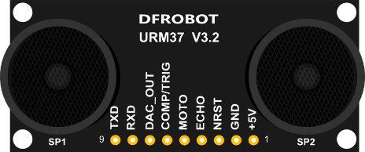

* DF05BB 5.1Kg 机器人专用舵机
* DF05BB 5.1Kg servo

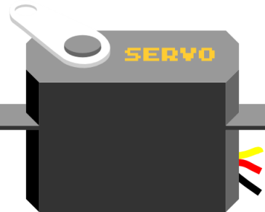

* DF05BB 5.1Kg 机器人专用舵机
* DF05BB 5.1Kg Robot servo support frame

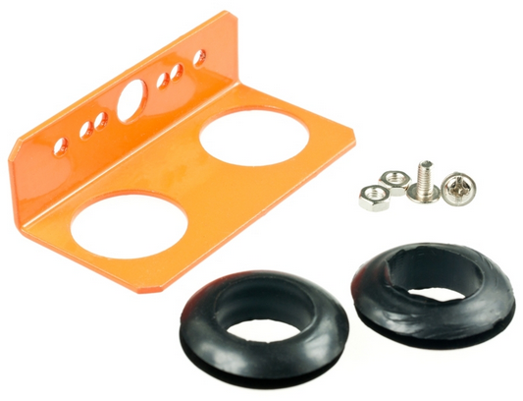

**组装步骤**

找到所有硬件材料后，就开始组装了，组装不难，更着操作就行。

**STEP 1: 摆放材料**

Assembly Directions

找到以下几个元件，使用的螺丝是舵机零件包所配的自攻螺丝。

Find the appropriate parts in your bag; make sure to prepare the necessary screws.

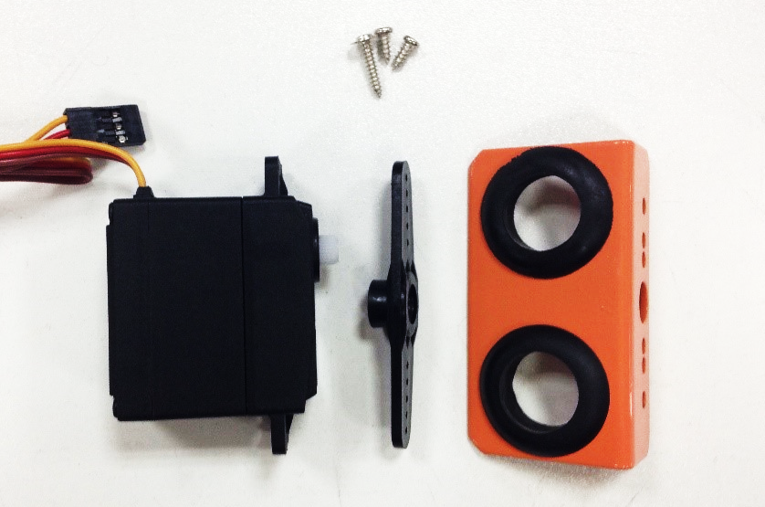

**STEP 2: 安装舵盘**

**Step 2: Assemble the servo**

找到舵机零件包中最长的自攻螺丝，用来安装舵盘。

Find the necessary screws to attach the servo horn to your servo. Screw in the horn as shown below.

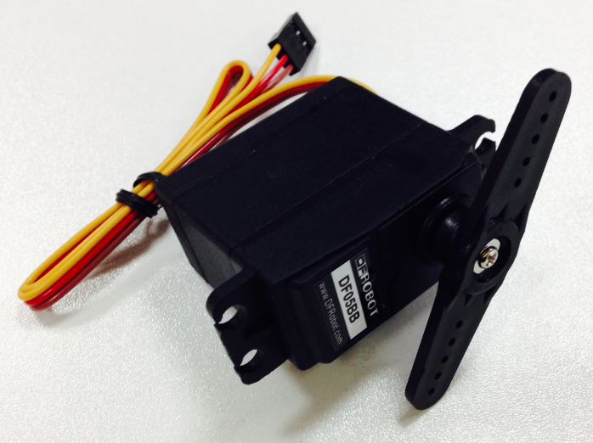

**STEP 3: 固定超声波支架**

**Step 3: Attach the ultrasound support frame**

这里同样需要使用到自攻螺丝，找到支架的对应孔位，拧上螺丝。

Here, we’ll need the self-tapping screws (see parts list if needed). Find the appropriate holes on the support frame and screw your servo in as shown below.

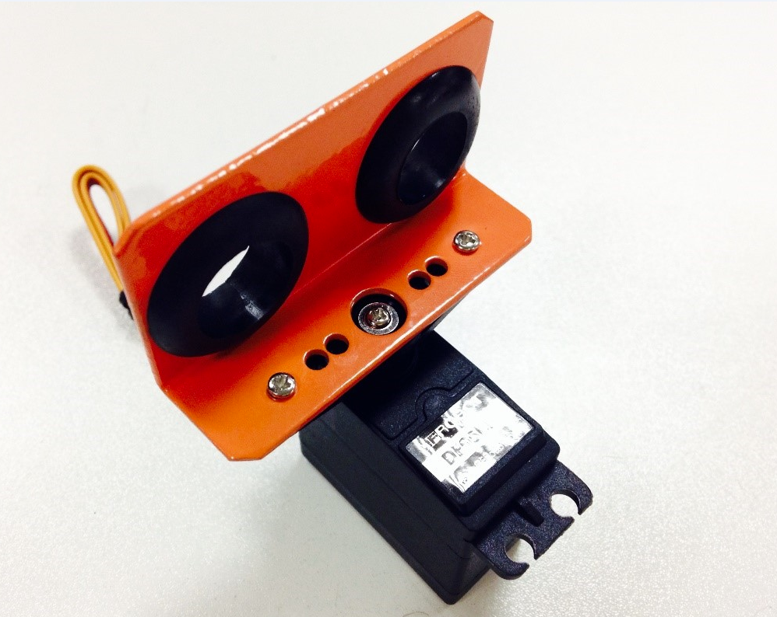

**STEP 4: 安装超声波传感器**

**Step 4: Assemble your ultrasound sensor**

最后将传感器固定到传感器支架上即可。

Next, attach and screw your sensor to the support frame.

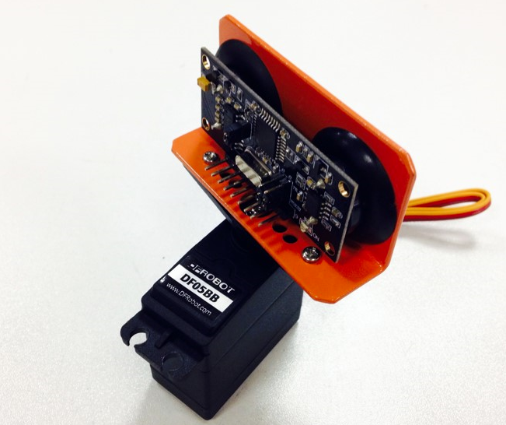

**STEP 5: 固定超声波传感器**

**Step 5: Attach the ultrasound sensor**

超声波传感器和舵机固定完成后，还需要将其安装到小车的上层板上。同样是4个M3螺丝和螺母，找到上层板上的4个舵机固定孔位，拧上即可。

After attaching the sensors to the servo, we now need to attach the servo to the top plate of the Pirate. After finding the four appropriate holes on the top plate, use four M3 screws and nuts to screw the servo into place.

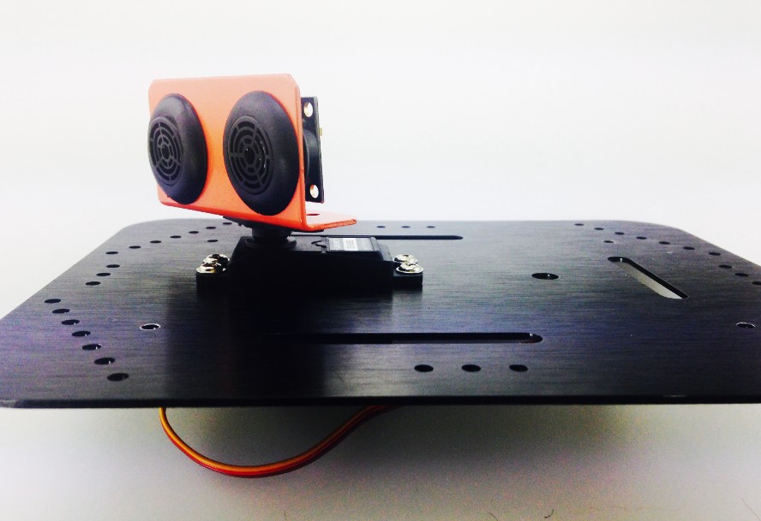

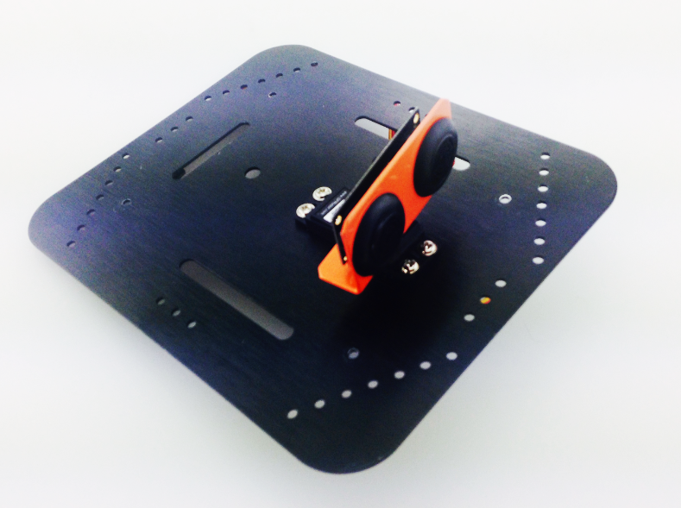

恭喜你，你基本已经完成安装了！先不要急着将上层板固定上去，因为传感器和舵机还没有接线。

Congrats, you’ve completed the first step in installing your sensors! Before attaching the top plate back onto the Pirate, we still need to solder the wires onto the microcontroller.

**硬件连接**

这里的接线不难，舵机连接到数字口10。连接超声波时，需要注意超声波引脚的引脚号。在超声波板子背后标有1,9字样可做参考。

Soldering the servo won’t be too difficult.

Solder the servo’s three wires to digital port 3. With regards to the ultrasound sensor, make sure to pay attention to the proper sequence in soldering its wires to the correct pins.

舵机 – D10 (黄色 – 信号线, 红色 – VCC, 棕色 – GND)

Servo - D10 (Yellow: Signal wire, Red: VCC, Brown: GND)

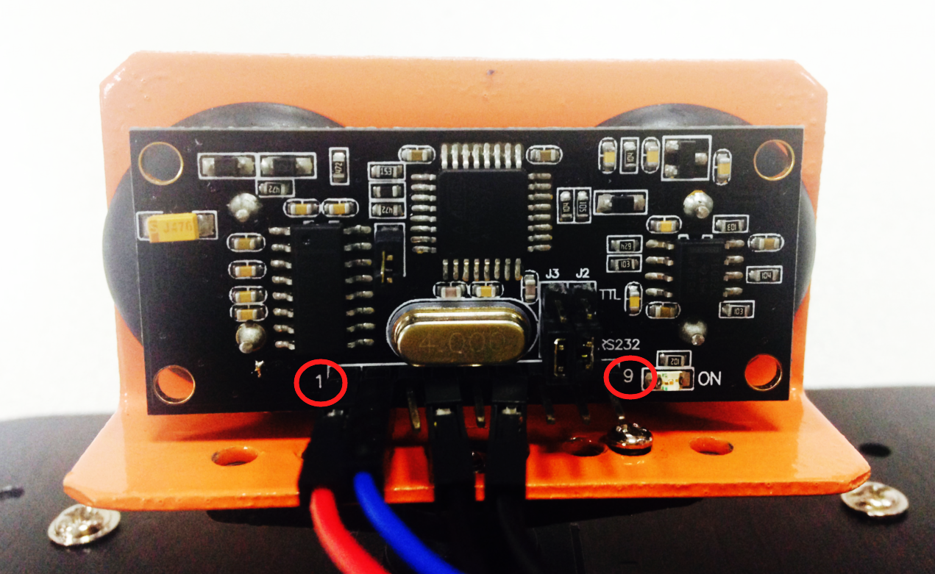

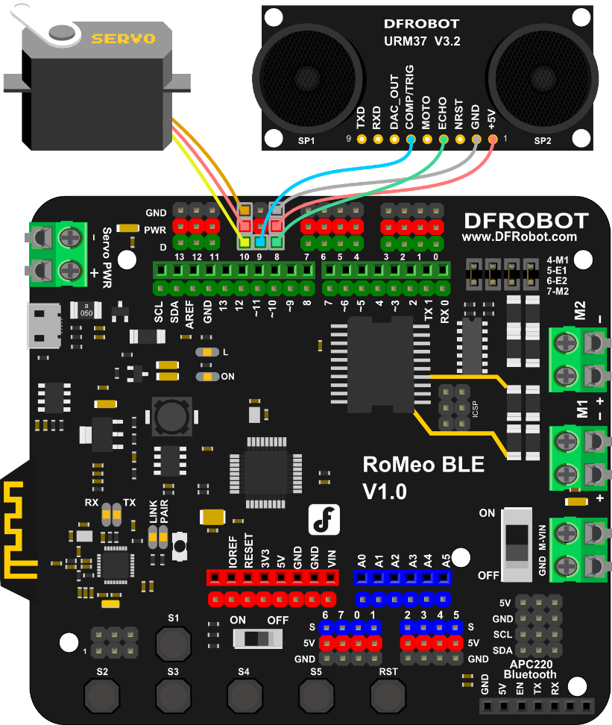

**传感器调试**

Adjust the sensors

**舵机调试**

Servo adjustment

舵机在开始使用的时候，我们需要对舵盘位置进行初始化，通常初始化为90°。如何设置呢？硬件连接不变，下载代码包中的Servo_Test.ino的样例代码。

In setting up our servo, we first need to configure and initialize it for use — in this case, we want to configure it to a 90° angle. How do we configure our servo? First, download and run the “Servo_Test.ino” sample code.

#include <Servo.h>

Servo myservo; // create servo object to control a servo

void setup() {

myservo.attach(10); // attaches the servo on pin 3

}

void loop() {

myservo.write(90); // tell servo to go to position in 90

delay(15); // waits 15ms

}

下载完成后，舵机是不是转到某个角度了？ 比如如下图所示：

After downloading and running the code, your servo should switch angles like in the picture below:

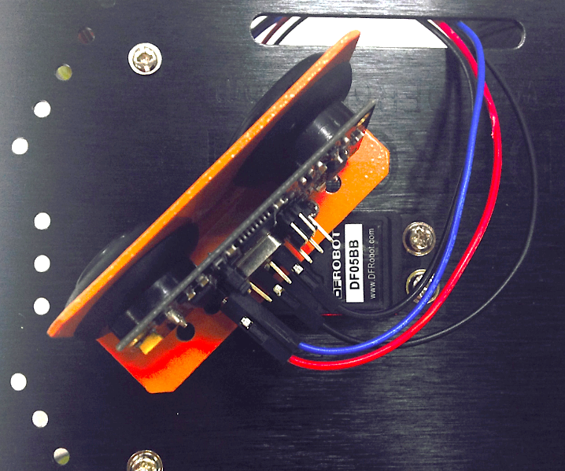

此时，不要拔下USB线！你需要做的事，取出传感器，拧下中间固定舵盘的螺丝。

During this process, do not unplug your USB cord! Instead, unscrew the middle screw attaching the servo in place.

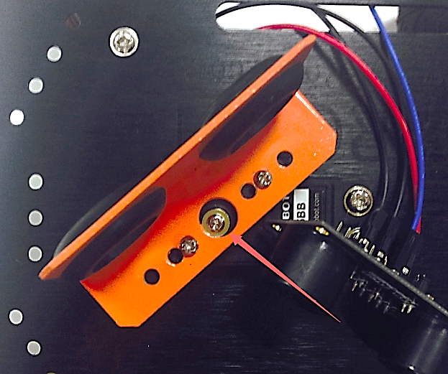 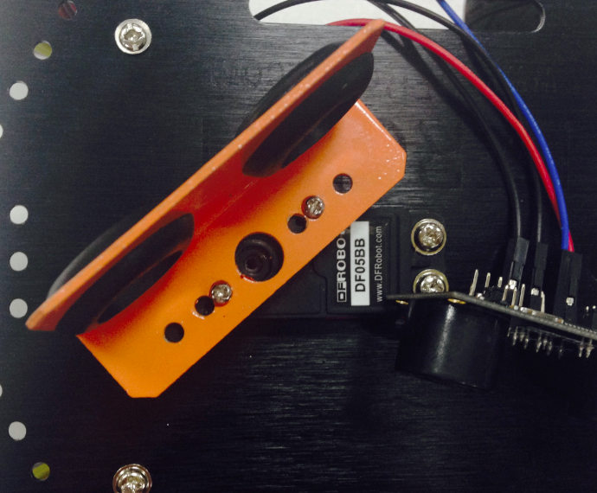

轻轻转动舵盘，你会发现舵盘转不动了。那是因为代码将舵机保持在了90°位置，舵机被锁住了。切记不要强行扳动舵盘！

If you try to gently prod the servo, you’ll discover that it’ll refuse to budge. This is because we’ve configured the code to keep the servo at a 90° position; the servo is locked at this angle. With this in mind, be sure not to forcibly pull or tug at the servo!

拔下固定在舵机上的超声波支架，重新摆放位置，将支架置于小车的正前方。再将超声波传感器装于超声波支架上。

Next, unscrew and remove the sensor support frame, then place it on the front of the Pirate. Re-attach the sensor to the sensor support frame.

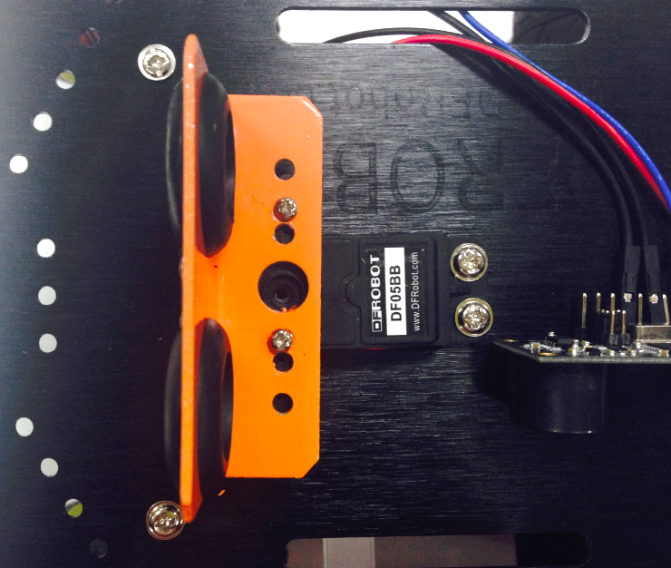 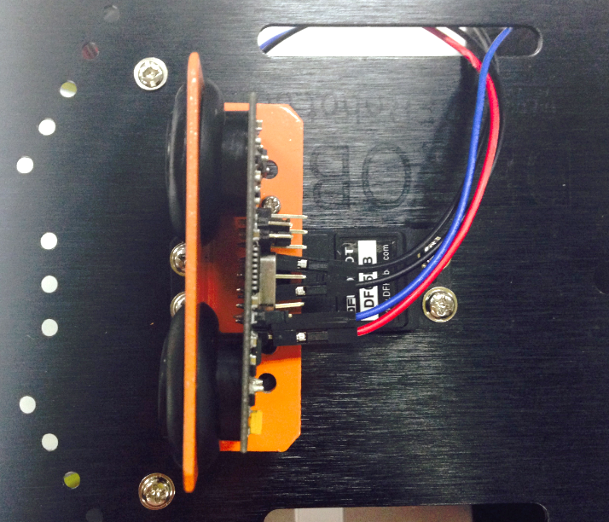

安装完成后，重新拧上舵机螺丝。现在，你可以将小车的上层板固定到小车底盘上。

After going through these steps, re-screw the servo into place. Then, re-attach the Pirate’s top plate to the base of the car as shown below.

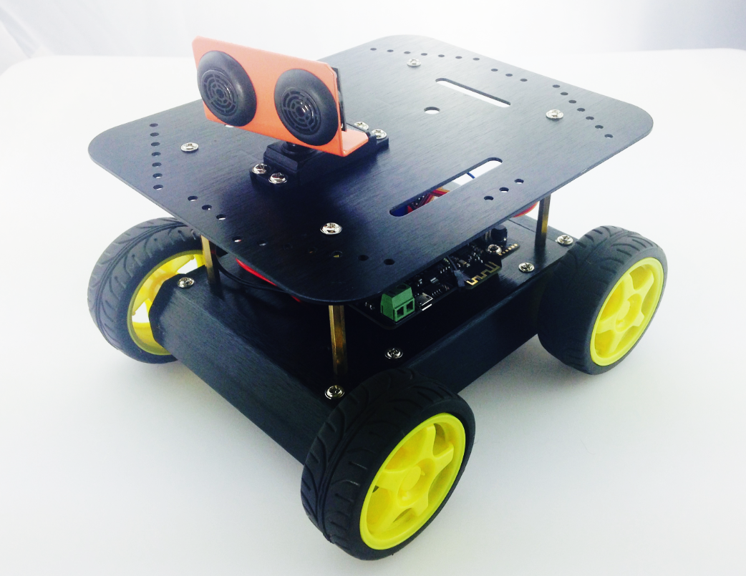

**输入代码**

**Coding**

由于代码较长，所以这里就不全部显示出来，你可在软件包中找到Avoidance_URM37.ino的代码，下载进去后即可。

Since the length of the code is relatively long, we won’t delve into all the specifics. . Download and run the Arduino code “Avoidance_URM37.ino.”

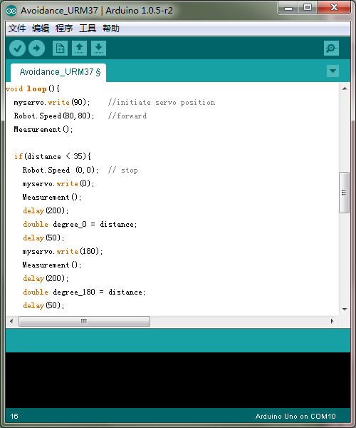

下载完成后，你就可以看到小车的避障效果了。当然，如果你觉得检测距离还不是很满意，也可以做一些微调。直到能正常工作。玩过之后，我们就来简单看下避障原理以及学习下代码，便于你能更好的改造你的机器人了。

After downloading the code, upload it to your Romeo microcontroller. Once your car starts moving, you’ll be able to see the obstacle avoidance sensors in action. If you feel like the sensor’s distance detection isn’t sufficiently strong, feel free to further adjust the sensors.

**避障原理**

Obstacle avoidance: how it works

通过下面a，b，c，d，e，f来简单看下如何通过三个传感器来实现避障。在前方没有障碍物，小车前行（图a）。一旦检测到前方有障碍物，先让小车停下，并且舵机转到0°检测下（图b），再让舵机转到180°，再检测下前方物体（图c）。判断一下，0°和180°前方障碍物的距离哪个更近，图中0°的距离更近。所以，小车开始执行后退（图d）,并且右转（图e）。直到前方不再有障碍物，小车恢复前行（图f）。

The following six diagrams (A, B, C, D, E, F) briefly illustrate how the three sensors work to avoid obstacles. At first, the car moves forward uninhibited (diagram A). Once it detects an obstacle, the sensors command the car to stop; the servo will shift to 0°, survey its surroundings (diagram B), then shift to 180° and survey its surroundings once more (diagram C). The sensors will process the readings from the 0° and 180° angles to determine which direction the nearest obstacle is in — in the case of the below diagrams, that would be the obstacle in the 0° reading (diagram B).

In light of that reading, the car will reverse (diagram D) and then turn right (diagram E) until it senses no objects in front of it; then, the car will continue to move forward (diagram F).

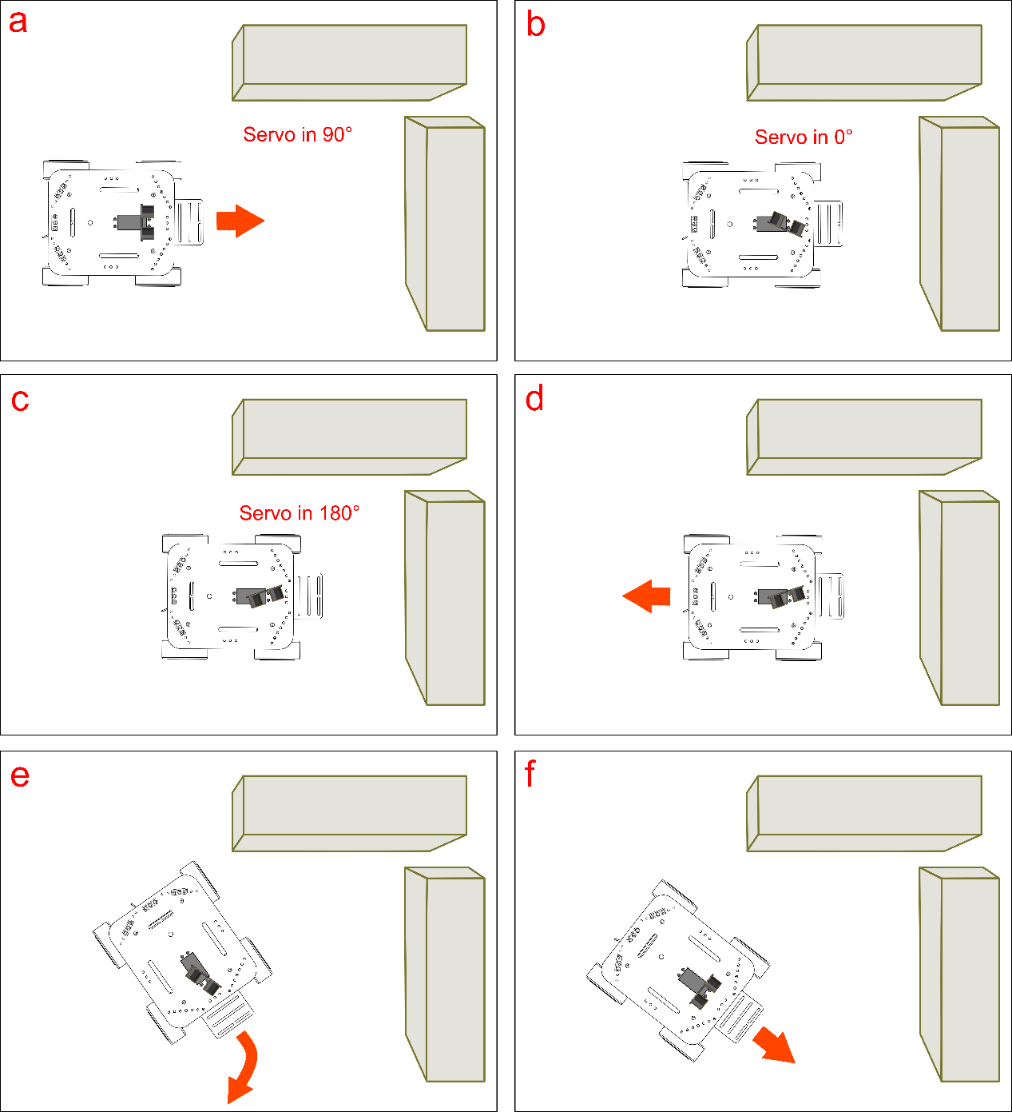

**代码回顾**

基础功能重复部分就不说了，只说下避障部分的。这里又用到，两个库Servo，URM37。Servo库是用来控制舵机的。URM37库则是传感器用来检测距离的库。

There’s no need to discuss the basic code – let’s just take a look at the part involving obstacle avoidance.

Here, we’ll be using two Arduino libraries — Servo and URM37. The Servo library is used to control the servo, while the URM37 library is used for the sensor’s distance detection.

#include<Servo.h>

Servo myservo; // create servo object to control a servo

我们在使用Servo库时，需要一开始对这个库声明一个对象myservo。

In order to use the Servo library, we must declare myservo as an object in the void setup() portion of our code.

#include <URM37.h>

ultrasonic URM37;

double distance; //prarmeters of infrared distance measurement

同样我们用超声波传感器时，也需要声明一个对象URM37，（URM37是超声波传感器型号）。变量distance是来存储超声波传感器读到的值。

We also have to declare URM37 as an object in order to initialize our sensor’s distance detection. The distance variable is used to store the readings from our sensors.

再看setup()函数中，电机部分由于在基础功能一节已有介绍，所以不做说明，如不明白，可以跳回到基础功能一节。我们主要看下舵机部分。

We won’t rehash the void setup() part of the code since we previously discussed this in the Basic Functions portion of this guide. Below, we’ll discuss the code that relates to the servo.

myservo.attach(10);

这句话是用来设置舵机引脚的，因为我们这里舵机接的是数字口10，所以代码中对应写入引脚10。当然，你也可以改成其他引脚，记得代码也要做相应修改就行了。

This line of code is used to configure the pin/port responsible for the servo. Since we soldered our servo to digital port 10, our code here initializes digital port 10. If you wire your servos to a different pin/port (i.e. port 11) and change your code accordingly (myservo.attach(11)), that will also work.

函数格式如下：

The function is as follows:

myservo.attach(pin);

这个函数就是用来初始化舵机的引脚的。

This function is used to initialize the servo pin.

接着往下，我们用到串口了，串口是什么？串口是Arduino和电脑之间通信的一种渠道。Arduino可以通过串口将数据发送给电脑，电脑也可通过串口将数据发送给Arduino。我们这里就是通过串口将Arduino从红外传感器中读到的数据发送给电脑。

After initializing the servo pin, we want to use the Serial function. What does Serial do? Simply put, it’s a channel for Arduino to communicate with the computer. Arduino uses Serial to send digital data to the computer — the computer can also use Serial to send digital data back to Arduino. Here, we use the function to enable Arduino to send the sensor’s digital readings to the computer.

在使用串口的时候，必须在setup()函数中进行一个类似于初始化的设置，也就是：

When using the Serial function, be sure to place it in the void setup() portion of your code:

Serial.begin(115200);

函数格式：

Serial.begin(speed);

该函数有一个参数speed，是用来设置波特率的。在一些特定的无线通信模块需要有一些特殊设置。如果只是串口打印数值，无需太在意。

同样，超声波传感器也需要设定一下引脚号，用到的函数是：

We also need to initialize the pin for the ultrasound sensor (plugged into pins 10 & 11 as shown in the diagram earlier in this guide). The function is as follows:

URM37.Init(10,11);

函数格式：

The function:

URM37.Init(UrmEchoPIN, UrmPWMTrigPIN);

该函数用于定义超声波传感器的引脚号，用于setup()中。

This function is used to enable the ultrasound sensor (URM37) for use — without this function, the sensor won’t turn on and send its readings. Make sure to place this function in the void setup() portion of your code.

程序走到主函数loop()，这部分内容最好结合上面的避障原理可能会更容易理解。先来看几个陌生的函数。

The below function should be placed in the void loop() portion of your code.

Now let’s take a look at some new functions.

myservo.write(90);

函数格式：

The function is as follows:

myservo.write(pos);

该函数是用来设置舵机角度。参数pos就是写入的角度值。

This function is used to configure the angle of the servo. The pos value corresponds to the angle that you want to fix the servo at (i.e. 0~180°).

当然这个角度也不是随便设置的，需要根据你选舵机决定的。我们这里选择的是180°舵机，所以可设角度也应该为0读~180°之间。所以，我们这里是这是舵机角度为90°。小车正常前行。接着往下，我们需要读取距离前方物理有多远距离。我们这里调用了一个代码内部的一个Measurement()函数。

We don’t want to set a random value for this function — optimal values are determined by the type of servo used. Here, we use an 180° servo; thus, we can select any value between 0~180°. In this case, we’ll input 90° as our value.

Next, we need to figure out how to get proper distance readings for the objects in front of our sensor’s path. To do this, we need to use the Measurement()function.

Measurement();

我们稍后再说这个函数，你只要知道这个函数是用来测距的就可以了。

We’ll talk more about this function in a little; for now, we just need to know that this function is used to detect distance.

接下来，我们就要开始做判断了，判断前方障碍物是不是距离太近了，小于我们设定的35了，如果小于35了该怎么做？大于35该怎么做？也就是这里用到的if…else的语句。

Next, we’ll be dealing with the code that determines object distance. The code sets out to determine how close an object is — here, we’ve set a parameter for how the car should move if an object is within 35 cm. To do this, we need to use the if…else function. Take a look at the code below and think about how you would make the car respond to objects less than 35 cm away or greater than 35 cm away

我们以通俗的话先来看下避障原理中涉及的逻辑分析。

Let’s check out the following to get a better sense of the logic behind obstacle avoidance.

if（距离 < 35）{

小车停下；

舵机转到0°；

读取0°位置离障碍物的距离；

再转到180°；

读取180°位置离障碍物的距离；

if（0°位置距离 > 180°位置距离）{

小车后退；

小车右转；

}

else{

小车后退；

小车左转；

}

}

else{

小车正常前进；

}

不知道以这样的形式，你是不是明白了，小车在碰到障碍物的时候是怎么处理的。中间有个0°位置和180°位置的判断，这是用来判别是左右两边哪个距离障碍物更近，使其朝相反方向运动。

This code illustrates the principles in the “Obstacle avoidance: how it works” section of this guide. Simply put: if the object is detected less than 35 cm away from the sensors, then the car will stop. Then, the servo will rotate to a 0° and 180° angle, respectively. The sensors will process the readings from the 0° and 180° angles to determine which direction the nearest obstacle is in — after making that determination, that car will reverse, then turn left or right until it senses no obstacles in its path, whereupon it will move in a forward direction again.

最后，我们回过来看Measurement()这个函数。如果对代码不感兴趣的童鞋，可以跳过这段。只有会使用这个Measurement()函数就够了。

Lastly, let’s return to the Measurement()function. This part is optional — skip it if you wish.

这个函数唯一做的一件事情就是，不断的采集值，然后比较采集的值中的最大值。

What this function does is continuously collect sensor values, then pluck the largest value among that collected group of values.

distanceBuffer[i] = URM37.Distance();

通过一个数组来存储读到的值，数组和我们前面说的变量的区别在于，数组可以存放多个值，而前面的整型变量只能存放一个值。

Here, we use an **array** to store the sensors different values. Unlike integer variables, which can only contain one value, **arrays** can store several values.

这里还涉及一个计算三个值最大的“公式”：

Below is a sample code containing three values:

max=a>b&&a>c?a:(b>c?b:c);

distance = distanceBuffer[0]>distanceBuffer[1]

&& distanceBuffer[0]>distanceBuffer[2]

?distanceBuffer[0]:

(distanceBuffer[1]>distanceBuffer[2]?

distanceBuffer[1]:distanceBuffer[2]);

将计算出来的最大值给到distance这个变量。用于前面说的if判断。

This code is used to determine the maximum value to assign to the distance variable. This code after an if clause (shown in the previous example).

如果我们想在电脑上看到具体读到的值是多少呢？就可以就下来两句话：

Serial.print(distance); //print out the value you read

Serial.println (" cm");

**如何串口看数值？**

How do we use Serial to observe the sensor’s values?

前面还保留了一个问题就是，我们如何从串口来看数值呢？在Arduino IDE上有个Serial Monitor（串口监视器）。

As mentioned before, we can use the Serial function to see the readings given by the sensors. The Arduino IDE has a Serial Monitor which can be used to track those readings as they’re being fed back to the computer.

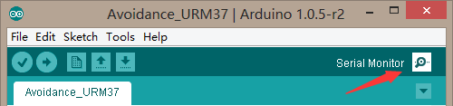

下载完代码后，点击一下，就会跳出如下的一个对话框。右下角有个下拉框，则是可以选择串口波特率的，需要与代码中保持一致。所以我们这里串口设置为115200。

After downloading the code and opening the Arduino IDE, click on the button labeled “Serial Button” as shown in the picture above. A box will appear. In the bottom right corner of that box is a drop-down menu that lets you select the baud rate. In selecting the baud rate, we want to be consistent with what we wrote in our code (i.e. Serial.begin(115200)). Since we wrote Serial.begin(1152oo) before, we want to select a 115200 baud rate in the drop-down menu.

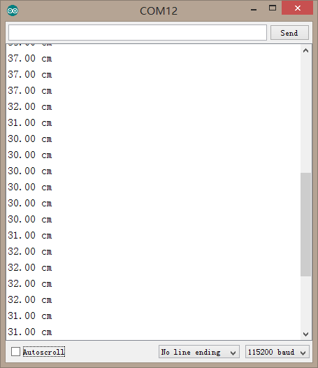

这样，你就可以根据读到的值，在代码中相应的修改。我们代码中设置的是35，你完全可以根据自己的需要设置为40等。

Based on the values of your sensors’ readings, you can tweak and modify your code to your liking. We’ve set our code to detect and respond to objects at a distance of 13 cm, but you can adjust your code to a value of 40 cm or whatever you prefer.

**大改造**

代码就讲到这里，我们这里做的是一个避障机器人。其实，同样的传感器，改造一下就能成为跟踪机器人了。只是方式相反，这里是，检测到物体后避开，跟踪的话，则是检测到物体后，向物体方向靠近。想一下，给自己做个跟踪机器人。

Interestingly, we can apply these same sensors to give our robot “tracking” capabilities. Unlike obstacle avoidance, which seeks to avoid detected objects, tracking capabilities command your car to follow an object once detected. Obstacle avoidance, tracking – these are powerful features that allow you to get creative. With this in mind, get to tinkering and having fun!